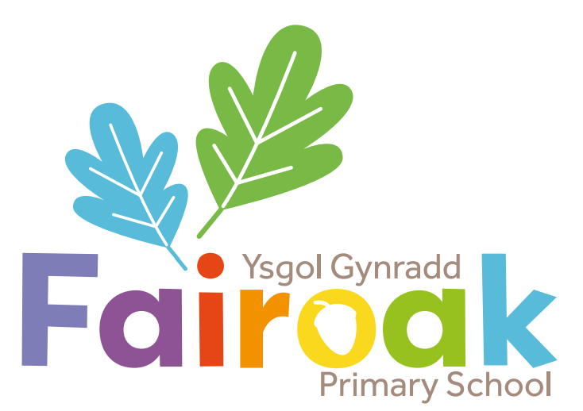

‘Learning and Growing Together’
‘Dysgu a Thyfu Gyda’n Gilydd’

Feedback and Marking Policy
Whole School Charter
Article 29: Education must develop every child’s personality, talents and abilities to the full
Article 2: Every child has a right to all the rights in the Convention on the Rights of the Child, without discrimination
Article 12: Every child has the right to be heard
Article 31: Every child has the right to relax and play
Article 15: Every child has the right to meet other children and join groups and clubs
Article 19: Every child has the right to be safe

Date reviewed: September 2025
Review Date: September 2026

Aims and Principles
Marking is a key element in the monitoring, assessing and recording of each child’s progress
as it informs appropriate future planning. The routine of marking also provides a good opportunity to allow the children to become reflective learners. We believe that marking should provide constructive feedback to every child in order to focus on success and improvement. Marking enables children to help close the gap between current and desired performance. Children need to know that their work is always valued therefore it is necessary that we adopt appropriate marking procedures.

Feedback & Marking should:
- Be manageable for teachers
- Relate to the learning intention, which should be shared with the children
- Give recognition and appropriate praise for achievement
- Respond to individual learning needs
- Inform future planning and target setting
- Be accessible to children
- Give children opportunities to become aware of and reflect on their learning needs
- Use consistent codes throughout the school
- Encourage children to self and peer mark where appropriate
- Raise pupils’ self-esteem

Teachers ensure that all written comments are appropriate to the age and ability of the child.
It is the responsibility of the class teacher to mark all work. It is unrealistic to expect that all marking be undertaken in depth, not every piece of marked work can include the next learning step and professional judgement will determine this.
When another member of staff is responsible for the class, they will need to ensure the work completed is marked.

Learning Intention and Success Criteria
At Fairoak Primary School, we believe that effective marking is an interactive process.
Wherever possible, children should be involved in the marking process. The Learning Intention (LI) is shared at the beginning of the session, as well as the Success Criteria. These should be differentiated to meet the needs of individual groups of learners. There should be frequent opportunities for children to review their learning and opportunities for self and/or peer evaluation throughout the session.

Beneath the LI will be the Success Criteria. These will be 3-star steps of progression to offer challenge to all pupils. A tick on the LI grid linked to the appropriate star shows what has been achieved.

LI: To tell the time using an analogue clock

Success Criteria | Self | Peer | Teacher
* read ‘half past’, ‘quarter past’ and ‘quarter to’
** to the nearest 5 minutes
*** to the nearest minute

Close the Gap Marking
Work should regularly be followed up with ‘close the gap’ marking or an extension question if appropriate. ‘Close the gap’ marking is denoted across the whole school by the use of a purple wand. This identifies where there are gaps in their learning linked to the success criteria or where an extension question has been given to extend the learning. Time is given to allow children to respond to their work either within the session or during allocated DIRT (directed improvement and reflection time) time for Year 3-6.

In addition, in PS2 (Year 1 & 2), we use the ‘Pink for Think’ and ‘Green for Great’ colour coding system. This offers visual feedback to young learners. Teachers will highlight specific pieces of work using a highlighter in green where work has met the learning intention. Teachers will highlight in pink where pupils need to make specific corrections, rewrite or improve the work.

Self-assessment
From Nursery to Year 2, pupils routinely self-assess using ‘Mr Men’ lolly pop sticks/stickers. Once a piece of work is completed, pupils select an appropriate sticker to evaluate their work; a comment is recorded next to the sticker by the member of staff (or where appropriate by the pupil). Mr Men characters are progressive – 2 in Nursery and Reception, 4 in Year 1 and 6 in Year 2.

From Year 3 to Year 6, pupils self-assess using ✓~ or ˳ on their learning intention grid. Marking Ladders are used to support self-assessment of the writing journey in LLC.

Peer-assessment
From Nursery to Year 2, pupils will peer-assess using Mr Men lolly pop sticks and stickers and their comment is recorded by the member of staff (or where appropriate by the pupil). The name of the pupil who has peer assessed should be recorded next to the Mr Man sticker. Peer-assessment should be alternated with self-assessment, increasing in frequency by Year 2.

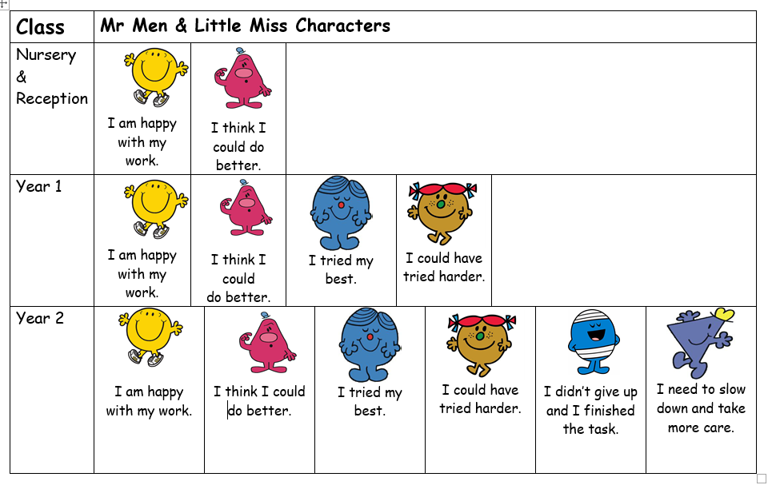

From Year 3 to Year 6, pupils will peer-assess in different ways. Pupils peer-assess using ✓~ or ˳ on their learning intention grid. ‘Pit Stops’ as used as editing/improvement time and work is often peer assessed. In addition to this the marking ladders have the opportunity for peer assessment, again using ✓~ or ˳ which shows attainment and areas to improve. The pupil writes peer assessed and their name.

Marking Criteria
Marking should focus on the success criteria. Comments may be made about spelling and presentation, when appropriate, but these should not be the main focus of any comments made.

The type of activity and any support provided, should be noted using the following codes.

I | Independent
MW | Modelled Writing
SW | Shared Writing
WS | With Support
P or G | Partner or Group Work
Ⓥ | Verbal Feedback

Presentation of Written Work
All exercise books should have printed sticky labels to show the pupil’s name, class and area of learning in English.

Progression Step 1 & 2 Pupils
- Work should be completed neatly, to the best of the pupil’s ability using pencil (black pen when appropriate in Year 3)
- Any changes can be crossed out with a single line
- When pupils self-mark and self-correct, this should be carried out in blue pencil or pen

Progression Step 3 Pupils
- Work should be completed neatly, using black pen with pencil used for maths and for tables or diagrams
- When writing titles, they should all be underlined with a ruler using capital letters where necessary
- Any changes can be crossed out with a single line
- When pupils self-mark and self-correct, this should be carried out in blue pen

Marking in Literacy & Maths
- Children’s work is marked with a purple pen by staff and initialled in order to make it clear who has marked the work. Supply teachers should also mark in purple pen but write ‘Supply’ next to it
- Indicate support and/or resources used
- The Learning Objective success criteria star should be ticked if achieved
- In extended writing tasks, the appropriate success criteria on the Marking Ladder should be starred if achieved
- A purple wand using the wand symbol indicates ‘close the gap’ marking or further challenge
- Basic punctuation (i.e. capital letters, full stops) should always be corrected. Incorrect use of capital/lower case letters should be circled. Incorrect punctuation of any other kind will be corrected according to the pupil’s particular knowledge, identifying missing or incorrect punctuation with a small line _
- Any reversed letters should be practised underneath the piece of work
- Any spelling corrections indicated by a ‘sp’ should be practised underneath the piece of work (please see p7 onwards for a full list of all marking codes for each year group)
- Maths books should be used as follows: Y1 books with 2cm squares, Y2, 3 & 4 books with 1cm squares, Y5 & 6 books with 0.5cm squares
- Correct answers should be ticked in maths.
- Any incorrect answers should be indicated by ● (not a cross). It can then be corrected by the child in blue pencil (PS2) or blue pen (Y3 & PS3). Corrections should be ticked and a small c inside a circle  placed beside them.
- Any reversed numbers should be practised underneath the piece of work
- Marking Codes, as below, to be used in all areas of learning, where appropriate from Year 3 to Year 6

Y3, 4, 5, 6 Marking for Editing Codes
When you see the below codes on your writing,
use the blue pen to correct.

[ = new paragraph needed
// = new line needed
= correct letter or punctuation mark

_ = missing punctuation (e.g. full stop, comma, etc)
qu = question mark
Ct = change word into the correct tense
^ = word needs to be added
Sp = check spelling
-> = change for a different word

